Philosophy  Students are our most important educational resource, and they require thorough preparation to meet the challenges of tomorrow. Each student should be accepted as he/she is and provided with experiences to achieve his/her goals.  Beliefs  The mental, physical, social, and emotional well-being of every student is of great importance, and every student should be provided with a secure environment and learning opportunities. Each student is unique and deserves equal opportunity to develop his/her talents and potentials. |  | KINDER CARE  PROGRAM  - 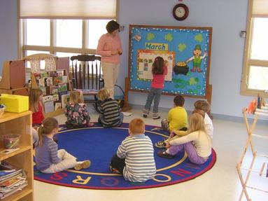

In collaboration with the kindergarten teachers our goal is to support and build strong foundations of continuity and enhanced learning through play. We believe children learn best through hands on experiences. This program will motivate, stimulate, and support children in their development of kindergarten skills and concepts. Through a variety of structured and unstructured activities, we will meet the needs of our students through social, physical, intellectual, creative and emotional role modelling. | What is Kinder Care?  We try to provide students with more opportunities to learn and grow.  The program includes:  - Exploration through play  - Language and literacy development  - Math and number recognition  - Arts and crafts  - Science experiments  - Messy play  - Books, puzzles, melting beads, dramatic play, center time  - Snack times, recess and outdoor play  - Wednesday public library where we have story time and art.  The Kinder Care program is staffed by Elk Island Public School Employees. | Program Days  This program will be operational on instructional days (as per EIPS calendar). KinderCare provides care for your child who attends a part-time Kindergarten program. Kinder Care runs on the opposite days of kindergarten. For example if your child is registered in the Monday/Thursday program they would attend Kinder Care on Tuesday, Friday and alternating Wednesdays.  We are a licensed facility and families may qualify for subsidy as administered through Alberta Children’s Services Child Care Subsidy at:  www. Childcaresubsidy.gov.ab.ca/  If you have any questions, please feel free to contact the school.  Contact Us  A.L. Horton Elementary School  5037-48 Ave.  Vegreville, AB  T9C 1L8  Phone: 780-632-3113

