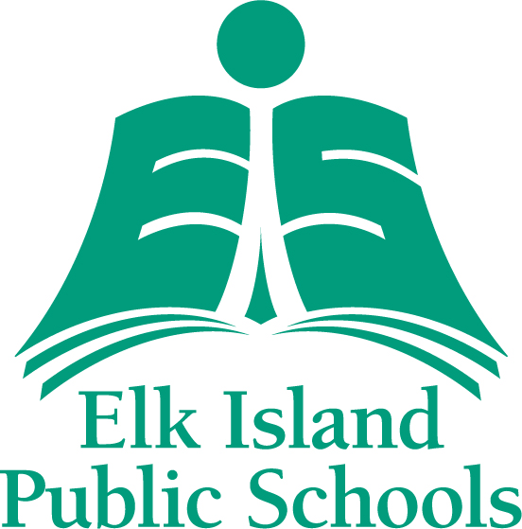 

**GOALS School Supply List**

**2025-2026**

Each student is responsible for the purchase of his or her school supplies. Following is a list of supplies required by **LINKS Goals** students for their first day of school.

**PLEASE HAVE ALL PROPERTY CLEARLY LABELLED WITH STUDENTS NAME.**

6 scribblers (interlined)

1 loose leaf (pkg of 250)

30 pencils (sharpened)

2 highlighters

4 erasers

1 ruler

2 red pens

1 markers (broad line, pkg of 12)

1 pencil crayons (pkg of 24)

1 pair of scissors

2 glue sticks

1 pencil case

1 good quality pencil sharpener with lid

1 headphones

1 pair of **white-soled non marking** running shoes **FOR INDOOR USE ONLY**

Extra set of clothes to be left at school in case of accidents/ playground mishaps

1 Ukrainian Blouse/Shirt ***(UKRAINIAN Language and Culture STUDENTS ONLY)***

**YOUR CHILD WILL NEED SKATES AND A CSA APPROVED HELMET WHEN WE GO SKATING**

**All materials need to be replaced as they are used or lost.**

**Please have students bring supplies on the first day of school.**